EXPERIMENT -12
You are designing a Task Management System for a small team. The system should include the following features:
1. User Login and Role Assignment
2. Task Creation and Assignment
3. Task Prioritization and Deadlines
4. Progress Tracking and Reporting
Prioritize these requirements using the MoSCoW and Kano models in Jira.
Step 1: Login
- Open a web browser and navigate to the Jira website.
- Login - https://id.atlassian.com/login
- Sign in to your Jira account using your registered email address and password.
Step 2: Create a New Project
- Click Create Project.
- Select Scrum
- Enter the project name as Task Management System.
- Choose Team-managed.
- Click Create.
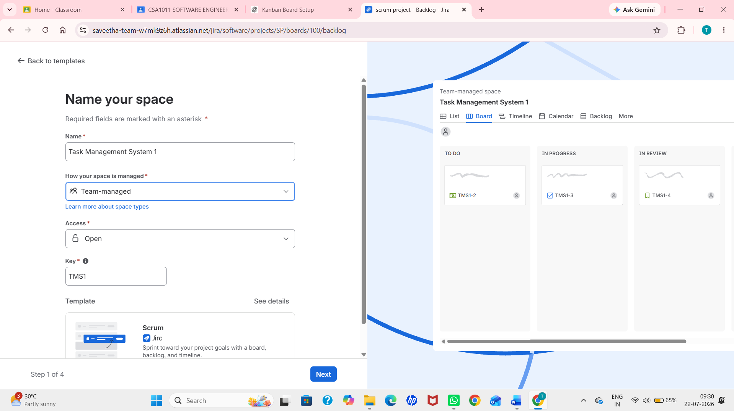
Step 3: Open the Backlog and Create Project Requirements as Tasks
- Select the newly created Task Management System project.
- Click the Backlog tab from the project menu.
- Create a new sprint if one is not already available.
- User Login and Role Assignment
- Task Creation and Assignment
- Task Prioritization and Deadlines
- Progress Tracking and Reporting
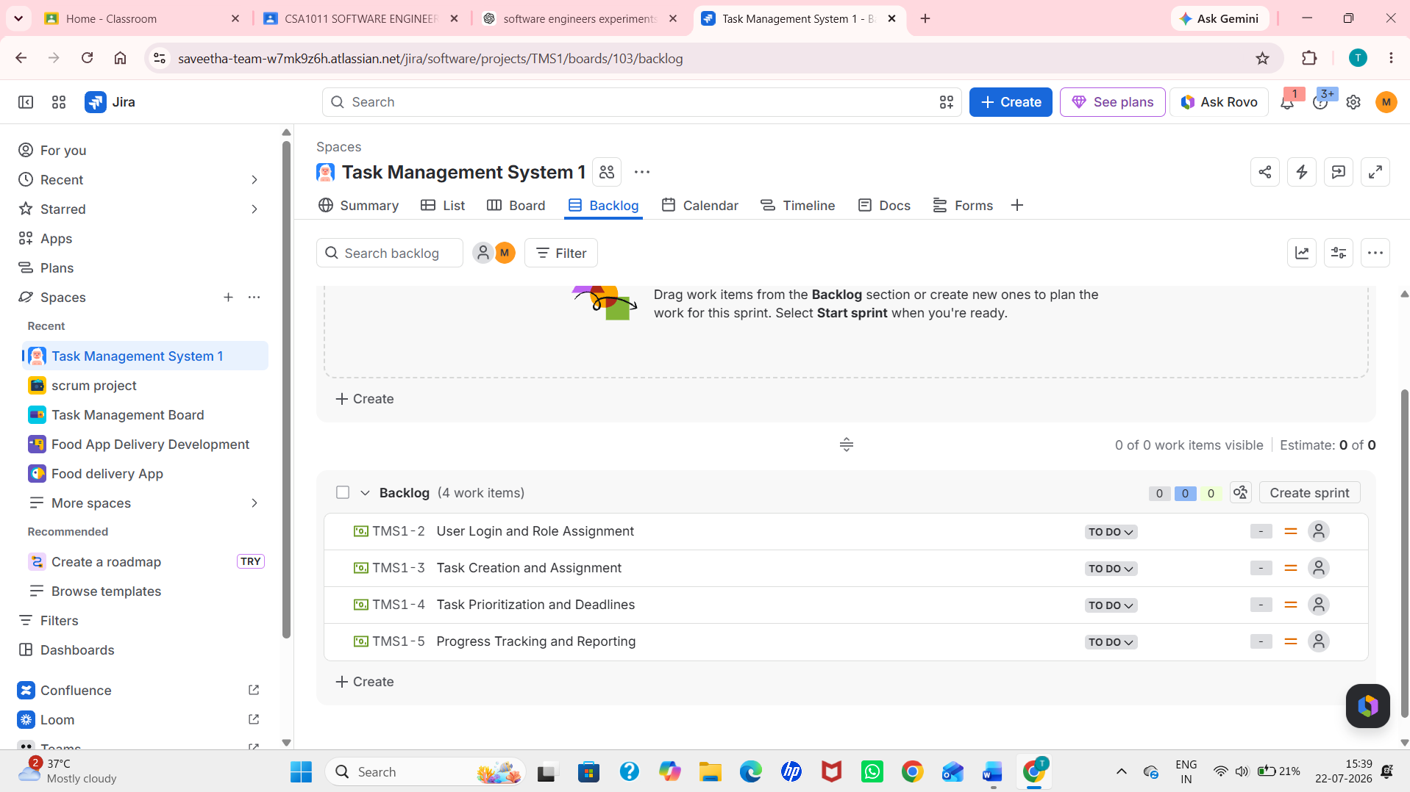

Step 4: Add Tasks to the Sprint
- Drag and drop all four tasks from the backlog into Sprint 1.
- Verify that all tasks are successfully added to the sprint.
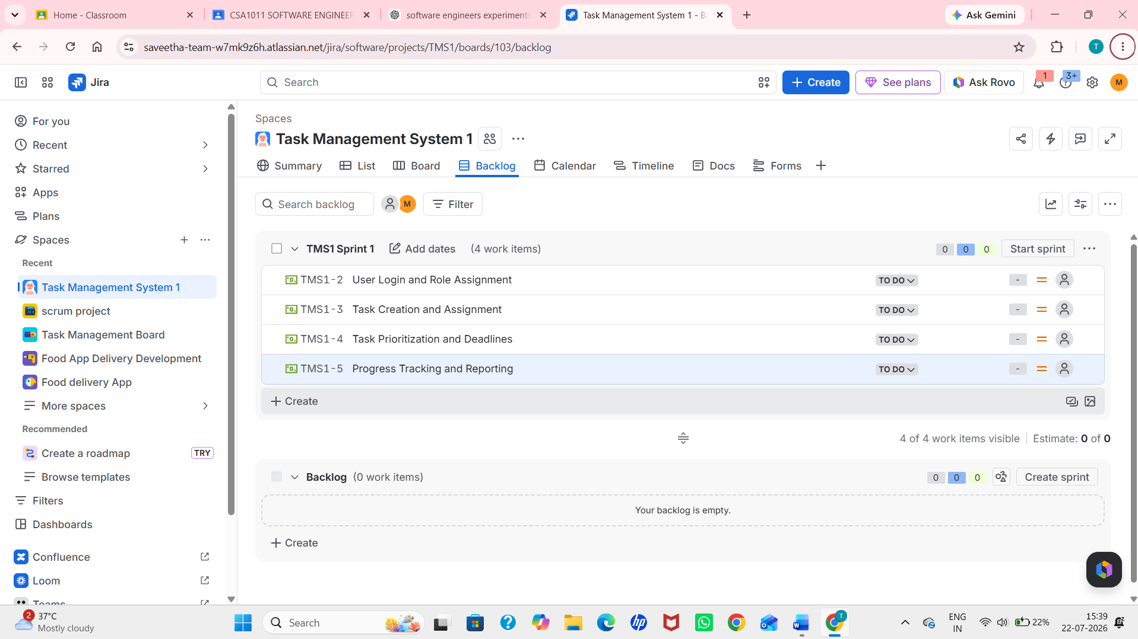
Step 5: Start the Sprint
- Click the Start Sprint button.
- Set the sprint duration to 1 Week.
- Click Start to begin the sprint.
Step 6: Prioritize Requirements Using the MoSCoW Model
Assign the following priorities to the tasks:
Requirement | MoSCoW Priority
User Login and Role Assignment | Must Have
Task Creation and Assignment | Must Have
Task Prioritization and Deadlines | Should Have
Progress Tracking and Reporting | Could Have
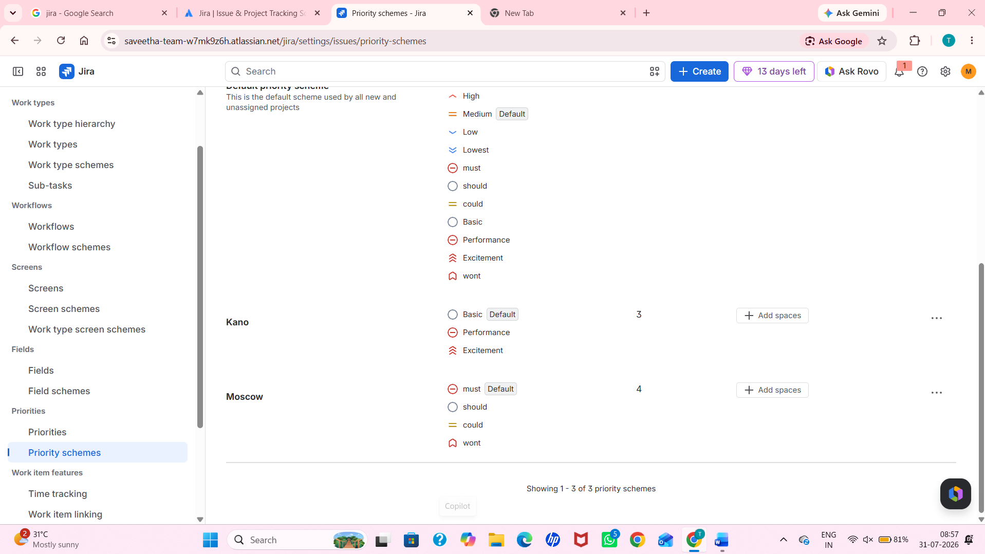
Step 8: Verify the Prioritization
- Open each task individually.
- Verify that the assigned MoSCoW and Kano classifications are correctly recorded (using labels, custom fields, or the method provided by your Jira setup).
- Ensure all tasks are displayed correctly on the Sprint Board.
Step 9: Capture the Output
- Open the Active Sprint board.
- Verify that all four tasks are visible with their assigned priorities and classifications.
- Capture screenshots of:
  - Scrum Project
  - Backlog
  - Sprint Board
  - Task Details showing MoSCoW and Kano prioritization

